**COFFEE**

**HERO**



Coffee is one of the world’s most popular beverages, valued for its bold flavor and natural caffeine boost. Flexicon bulk material handling equipment is designed to gently and efficiently convey coffee during processing and packaging operations.

Button: Talk To Us

**SHELF #1 - PRODUCT DESCRIPTION**

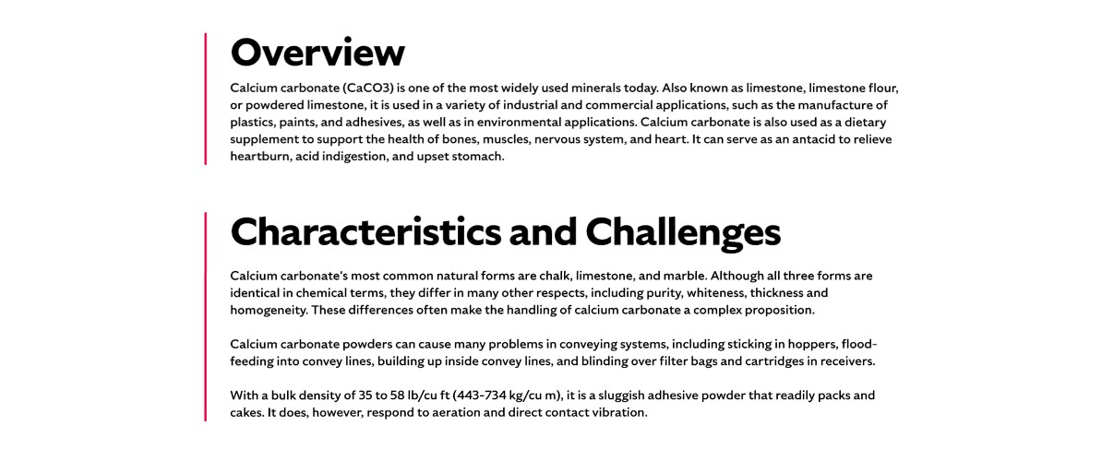

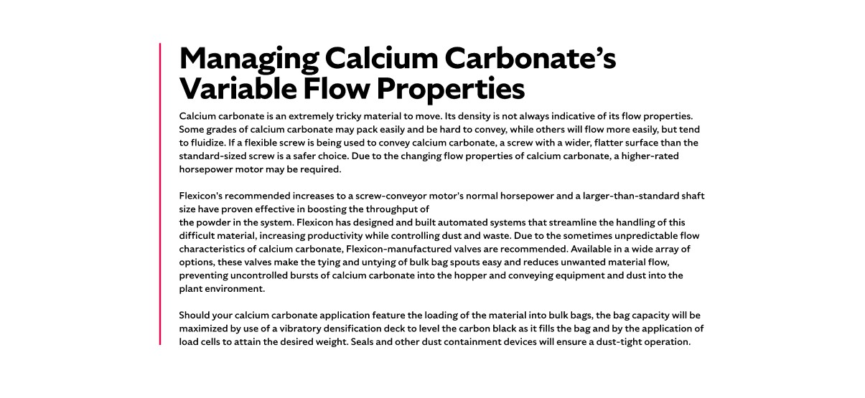

**Overview**

Although commonly referred to as a bean, coffee is actually the seed of the coffee plant. It has long been a major cash crop and key export for many equatorial nations. The United States is the world’s largest importer, with an estimated 150 million adults consuming coffee regularly. Flexicon systems are engineered to preserve the integrity of both whole beans and ground coffee, while supporting the demands of high-volume production.

**Characteristics and Challenges**

The density of a coffee bean affects both the strength of the brew and its packaging requirements. When coffee is packaged for bistros or aficionados who grind it themselves, it’s essential to prevent degradation of the whole bean or ground form. This requires equipment that can withstand the abrasive properties of coffee.

Coffee beans are delicate and can crack or lose their kernel if conveyed too aggressively, which may compromise flavor and overall product quality. Flavored coffees—whether whole bean or ground—require special handling, as added oils and powders can cause equipment buildup and increase the risk of cross-contamination. Effective coffee handling demands equipment that minimizes breakage and prevents flavor transfer. Flavored varieties also require thorough cleaning between batches to ensure product purity and hygiene.

**SHELF #2 - FLEXICON SOLUTIONS**

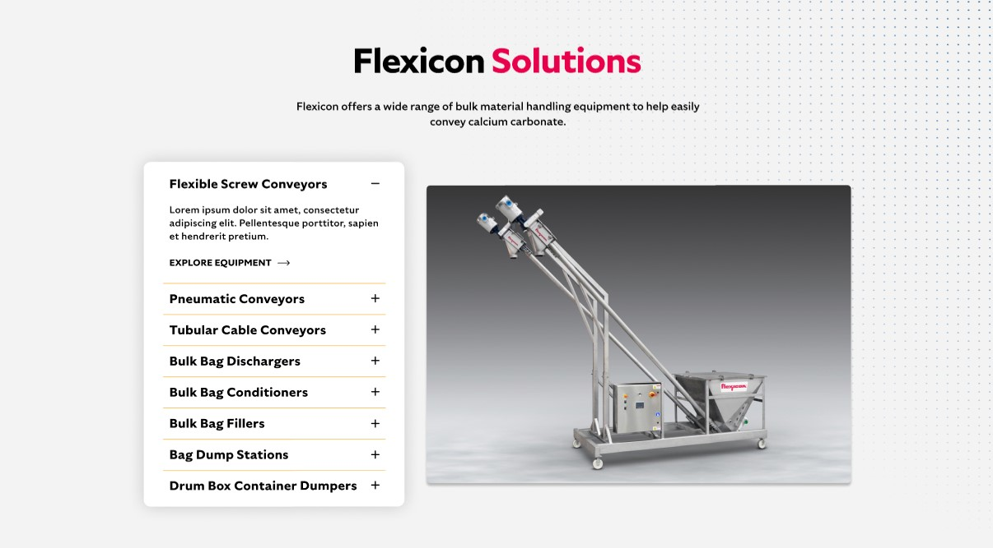

**Flexicon Solutions**

Flexicon offers a wide range of bulk material handling equipment to help easily convey coffee.

* **Flexible Screw Conveyor:** Gently convey whole or ground coffee without damaging delicate beans or causing separation.
* **Pneumatic Conveyors:** Enclosed systems maintain cleanliness and prevent dust during high-speed coffee transfer.
* **Tubular Cable Conveyors:** Ideal for moving coffee through complex routes with minimal breakage and contamination.
* **Bulk Bag Dischargers:** Enable safe, dust-tight unloading of coffee from bulk bags into downstream systems.
* **Bulk Bag Conditioners:** Loosen compacted coffee in bulk bags to ensure consistent flow during discharge.
* **Bulk Bag Fillers:** Accurately fill bulk bags with roasted or ground coffee while minimizing dust and spillage.
* **Bag Dump Stations:** Allow manual dumping of coffee with integrated dust control for a cleaner work environment.
* **Drum Box Container Dumpers:** Safely transfer coffee from smaller containers into processing lines with minimal manual handling.

**SHELF #3: LIFETIME PERFORMANCE GUARANTEE**

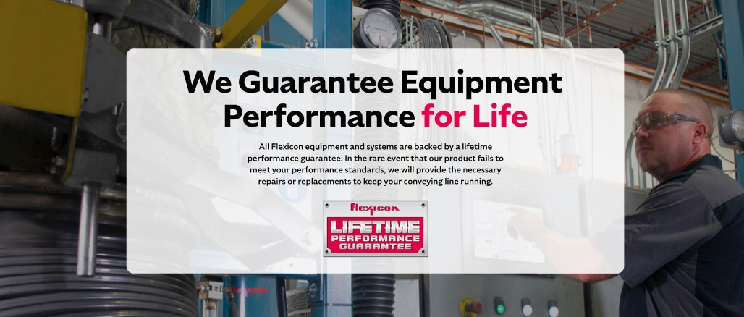

**Lifetime Performance Guarantee**

All Flexicon equipment and systems are backed by a lifetime performance guarantee. In the rare event that our product fails to meet your performance standards, we will provide the necessary repairs or replacements to keep your conveying line running.

**SHELF #4: CASE STUDIES**

